THEORY QUESTIONS
1.
(a)

In the space provided below, draw a well labelled computer mouse.
(b)

Outline the steps involved in performing the following tasks:
(i)

opening a document;
(ii)

saving a new created document;
(iii)

changing the desktop of a personal computer.

2.
Identify the following ICT tools:
(a)

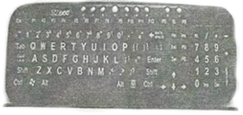
(b)

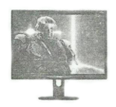
(c)

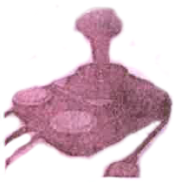
(d)

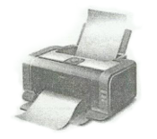
(e)

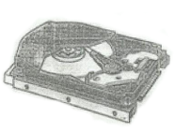
(f)

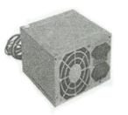

3.
State two differences between
(a)

random access memory and read only memory;
(b)

hard disk and pen drive;
(c)

file and folder.

4.
(a)

Explain the term clicking as used in the computing environment.
(b)

In a typical application window, list two command buttons that are found on the control menu.
(c)

What is a screen tip?
(d)

Describe a computer mouse pad.

5.
State the use of the following email terminologies:
(a)

Carbon Copy;
(b)

Blind Carbon Copy;
(c)

To;
(d)

Subject.

